**Question 37. (8 marks) [from WATP Sem II 2013]**

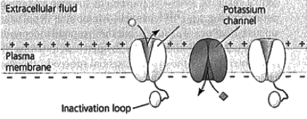

A

The diagram above represents an axon of a nerve cell membrane prior to an action potential occurring.

(a) What substance would be able to pass through structure A when an action potential occurs? (1 mark)

*sodium ions (1)*

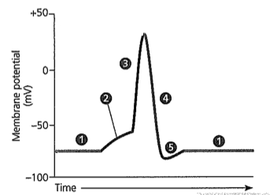

Diagram 2

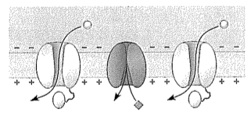

(b) Which part of the action potential shown in the graph above (1, 2, 3, 4, or 5) would Diagram 2 depict? (1 mark)

*Depicts part 3 (1)*

(c) Explain how a sodium potassium pump maintains the level of ions required for a resting nerve cell

membrane. (3 marks)

*transports sodium to the outside of the cell (1)*

*transports potassium to the inside of the cell (1)*

*moves more sodium out and less potassium into the cell / moves 3 sodium out for every 2 potassium in (1)*

(d) Ouabain is a substance extracted from an African plant by the Somali people who use it to poison their arrow-heads in order to kill animals. A sufficient concentration of the chemical can bring down a hippopotamus. Scientists now know that ouabain prevents the sodium-potassium pumps in nerve cell membranes from working. In the presence of ouabain, what change would you expect to see in the resting potential of a nerve cell? (1 mark)

*higher resting membrane potential / higher positive potential inside the cell (1)*

(e) State two (2) ways in which the speed of action potentials can be increased.

(2 marks)

*myelin sheath / short distances to travel / wider diameter of axon (Any 2, 1 mark each)*

Question 33 (9 marks): [from WATP Sem I 2016 Paper]

Use the graph below to answer the following questions.

1. Explain what is occurring at the phase indicated by the letter ”C” (3 marks)
   * **Sodium channels open,**
   * **sodium ions move in,**
   * **cell membrane becomes depolarised**
2. (4 marks)

Unmyelinated – action potential moves along membrane continually (1) Slower than myelinated (1)

Myelinated - action potential jumps from node of Ranvier to node of Ranvier or explanation of salutatory conduction (1)

Impulse travels quickly/quicker than unmyelinated (1)

1. (2 marks)

more receptors are stimulated (1) depolarisation of more nerve fibres the more stimulus/with heavy metal (1) produces more nerve impulses in a given time (1)